**How to integrate VS-Code with GitHub?**

Step 1. Open your project on VS-Code.

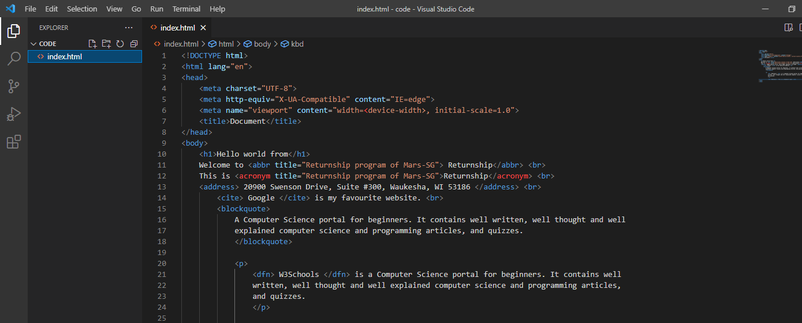

Step 2. Click on source control icon as highlighted:

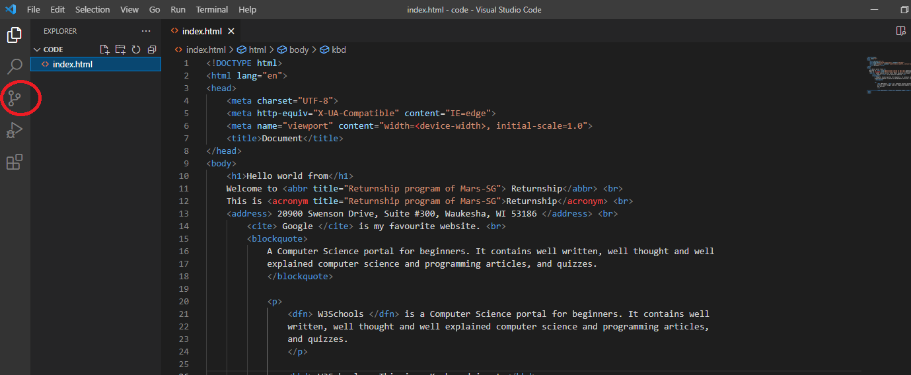

Step 3. Click on initialize repository:

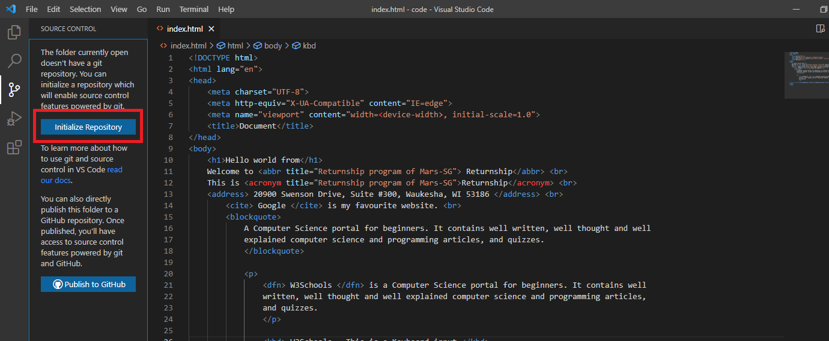

Step 4. You can see untracked files marked with ‘u’

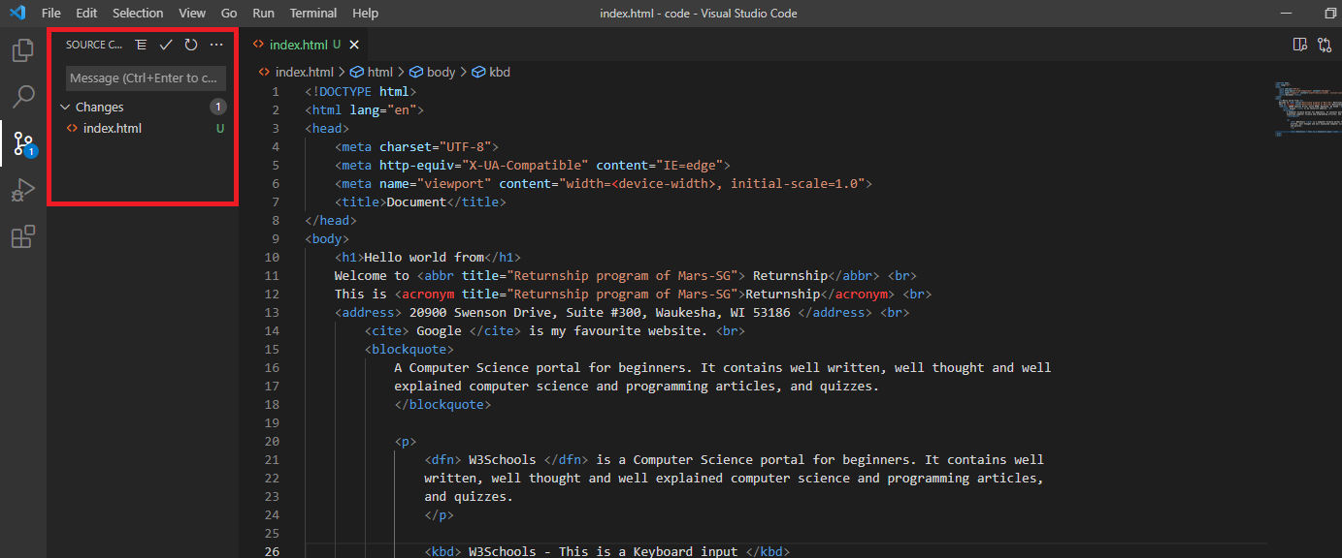

Step 5. Click on the ‘+’ symbol to stage the changes. (‘u’ will change to ‘A’)

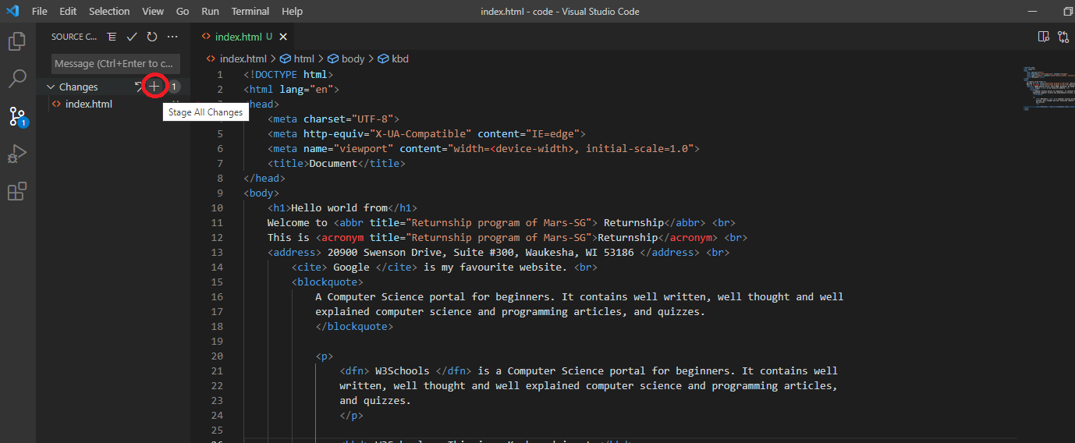

Step 6. Put some message in the message box and hit the check icon.

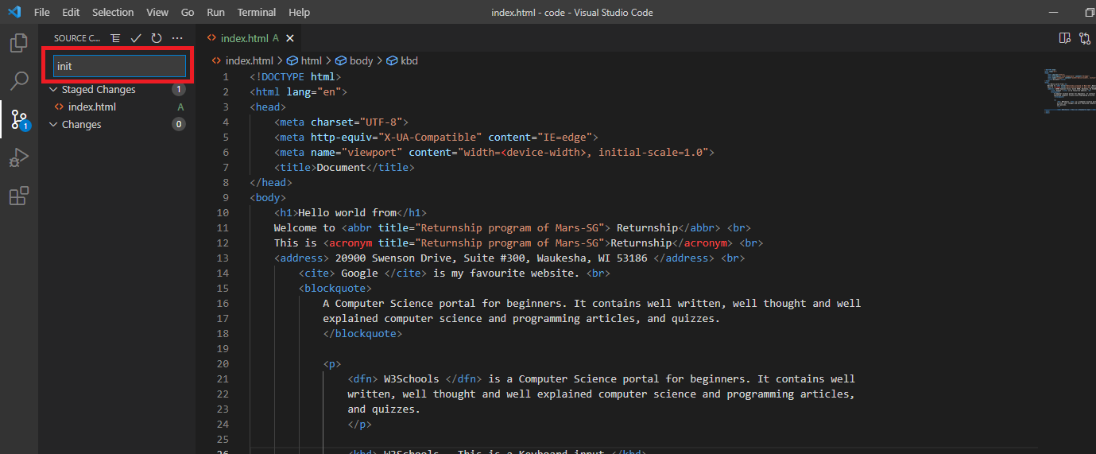

You may get an error like this:

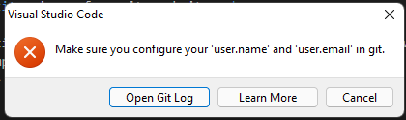

Step 7. Go to view->command palette

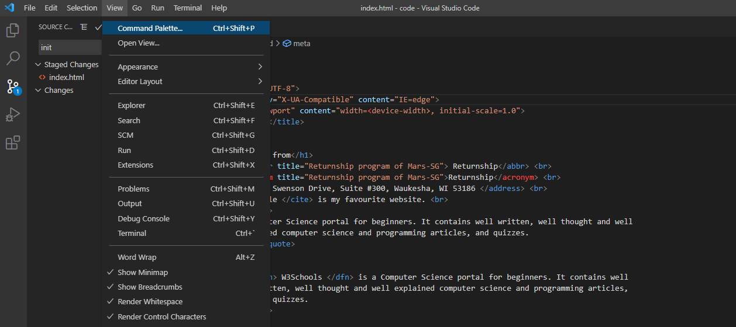

Step 8. Type “git” on the command palette and select the first option “Git:Add Remote”

Enter a name for your local repository and press enter

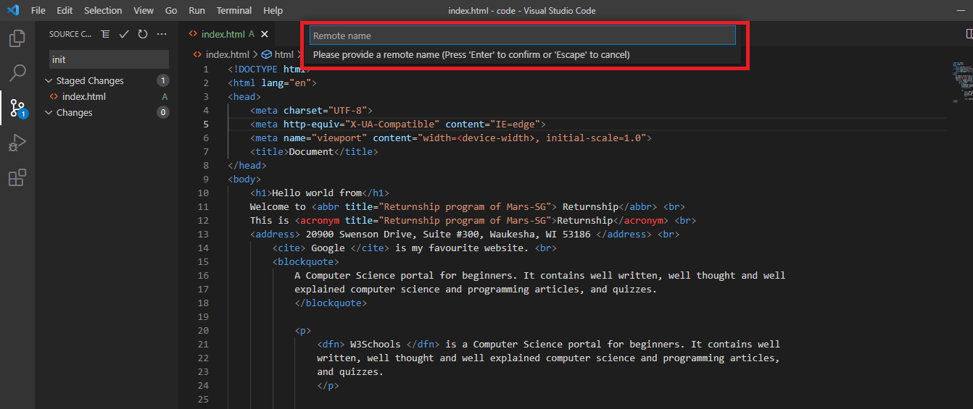

Step 9. Put your github repository url now: (If you don’t have github account, create it from <https://github.com/>)

Once your github account is created, sign in and create a Repository:

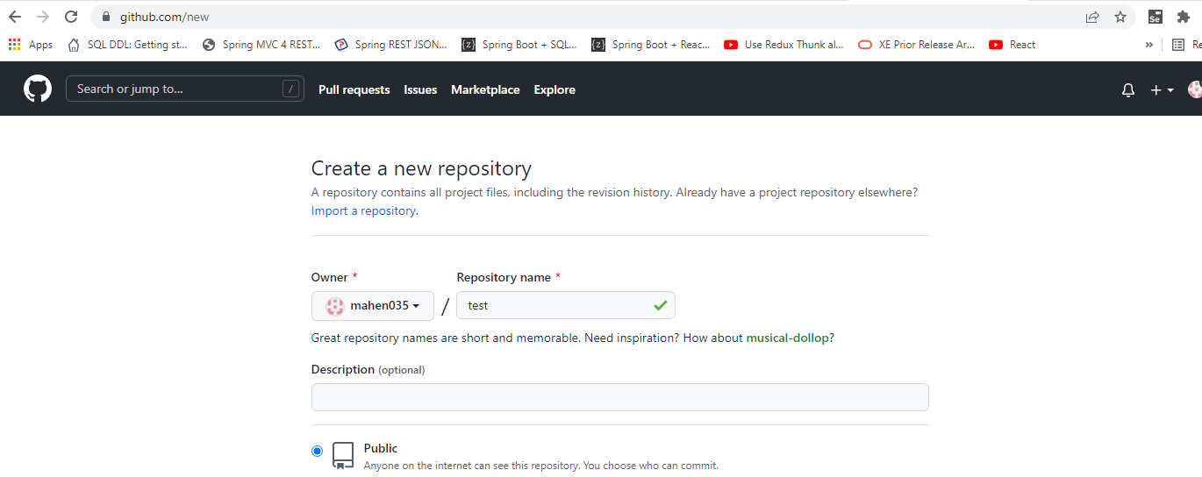

And then copy your repository url:

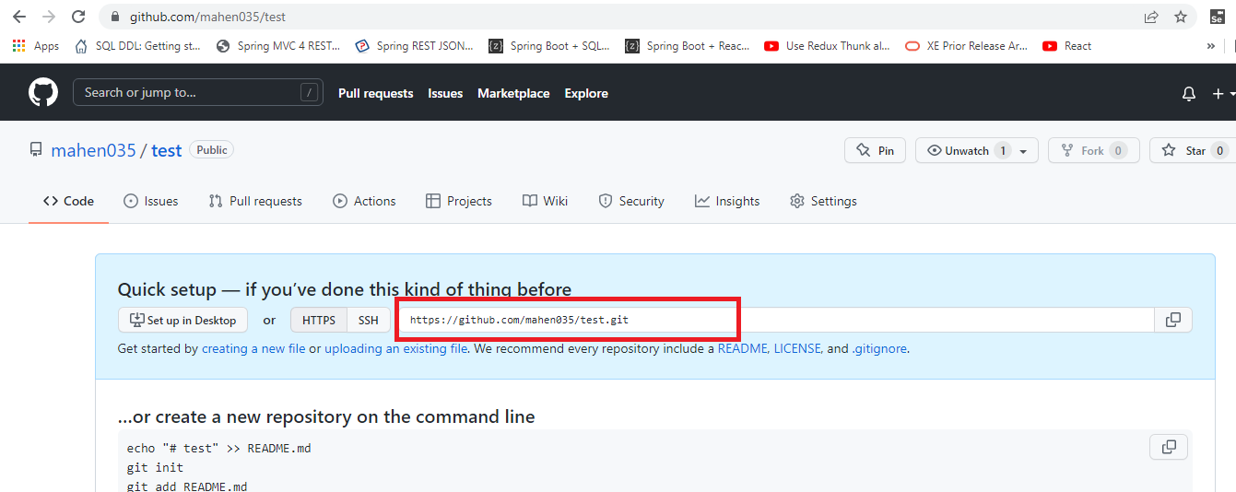

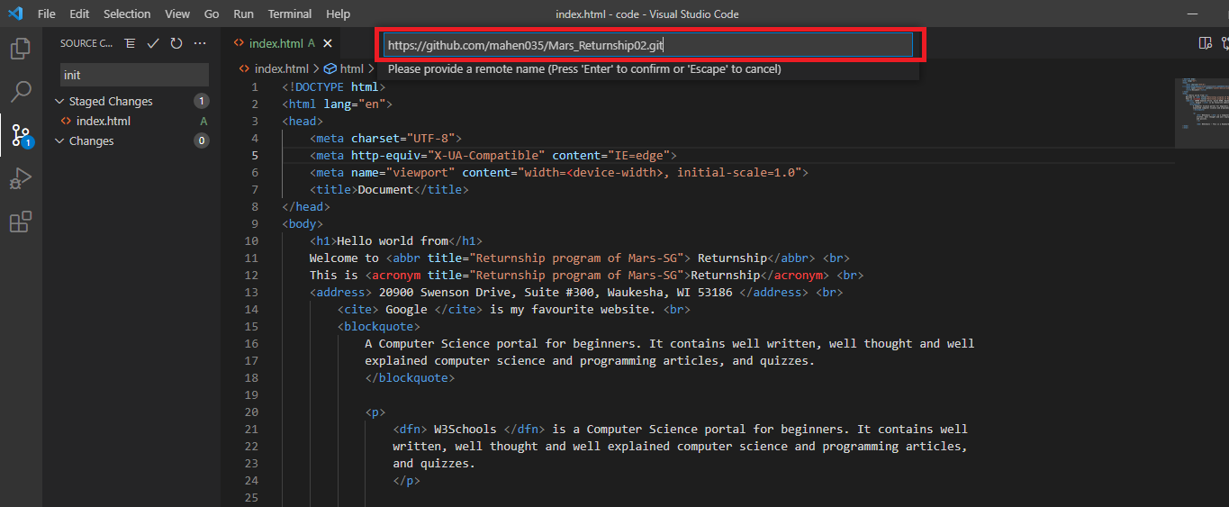

Step 10. You should be able to publish your code to GitHub now.